* Reading5  
  *Lonneke Lammers  
  10371672*
* Questions

1. Ware argues that human perception involves 2.5 dimensions. Given this assertion, when might a 3D visualization be useful and why?
2. In Chapter 6, Ware presents some implications of pattern recognition and visual working memory on design. Provide an example that harnesses some of these principles (perhaps an advertisement, visualization, or interface) and discuss how the design takes these principles into account. Please include a screenshot, photo, or website URL.
3. According to Bostock et. al., what are the primary advantages of D3? Based on your reading of the article, please provide an example of a type of visualization that would be easier and better implemented in D3 as opposed to HTML5, JSON, and Javascript. Please list the pros and cons of choosing D3 over pure HTML5, JSON and Javascript.
4. Of the visualization figures presented in Heer et. al., which do you find the most difficult to comprehend? Does the complexity of the figure interfere with the goal of visualization as described in the article? Include a screenshot of the figure you have chosen in your response and use principles that you have learned so far (i.e., from design, perception, and cognition) to justify your choice.
5. Play around with the interactive graphs included in the Heer article. You need to open this page in a browser that runs Java. Focus on Figure 1A. To what extent do interactivity and transitions, elements that D3 optimizes, add to the clarity and message of the visualization? With the element of interactivity in mind, redesign and sketch the contents of figure 1A with one of the other visualization types described in the Heer article. Include a picture of a sketch of your idea, and describe how it supports comprehension and data exploration.

* Answers

1. You can use 3D visualization when you want something to stand out of a particular visualization. When you make use of 2.5D visuzalization for example, you make the objects that are important for the visualization in 3D and might make some other things like lines and connections in 2D. Sometimes it will be more clear for a picture when some things are 2D and some things are 3D, and not everything in the same dimension. Also Ware describes that affordances are ultimately about linking perception and action, and that there are pathways in the brain that are specialized for this task. This also influences the human perception, in what you link with your eye-movements. Sometimes you already make something 3D because it’s a familiar object, and therefor is better to represent 3D because it looks more ‘normal’. When you want to show a cube, 3D seems necessary because otherwise it’s just a square.
2. Ware describes the following:   
   “An entity in visual working memory can be thought of as a temporary grouping or nexus, hereby links are formed between active visual patterns derived from the visual image on the retina scene information and information relating to non-visual stored meanings. Th e most important of

these non-visual links is information held in verbal working memory.”  
Also he describes the difference between explicit and implicit long-term memory. Where there is more implicit long-term memory in people’s head, the explicit memory is more special because we can communicatie about it, which is not possible with implicit lont-term memory where we can not explicitly recall. For explicit learning of visual patterns and associations to occur, Ware says that these patterns must be the focus of attention, at least momentarily, and then make in into visual working memory. In addition, in order for long-term memory traces to be formed it is necessary for 24-hour consolidation to occur.

An implication is that visual working memory has a capacity of between one and three objects, which depends on its complecity. And also this similar number can be held in verbal working memory. Also visual working memory capacity is something that critically influences how well a design works.

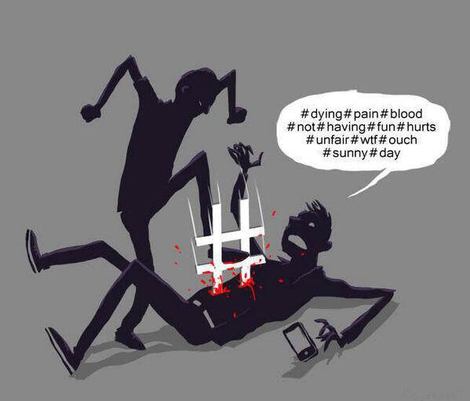In the image beneath I’ve chosen you see two people, where one seems to be killed by the other one. You can see these more 2D black things are people because of the hands, head etc., the posture of a human being. For me it took a while before I saw with what kind ob object the standing person hurts the other one in the belly. Because when I think about hurting someone in a body where you can see blood, this normally is done with something sharp like a knife, or for example a gun or other real weapon. In my mind a ‘hashtag’ is not really a weapon.

<https://www.google.nl/search?q=too+many+to+see&source=lnms&tbm=isch&sa=X&ved=0ahUKEwjtmfO216bJAhWFfg8KHXkSACMQ_AUIBygB&biw=1497&bih=814&dpr=0.9#imgrc=AMAjN47NR6jrkM%3A>

1. 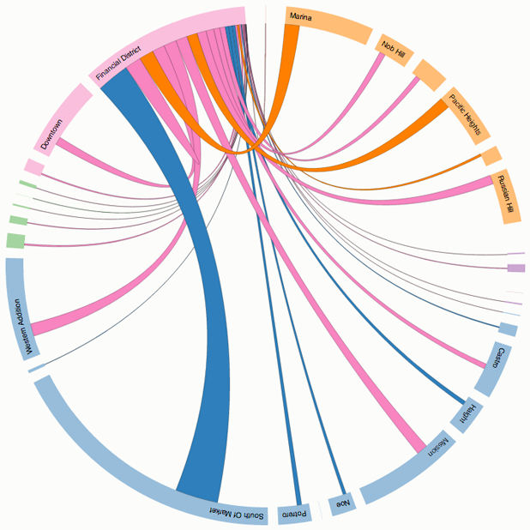D3 is not a traditional visualization framework: it deals directly with graphical marks and provides a close cognitive mapping between the toolkit representation and the desired result. Low level graphic libraries such as Processing and Raphael are not really nice for complex visualization tasks because they lack convenient abstractions. D3 directly maps data attributes to elements in the document object model. It depends on the context whether this is a great advantage, but a lot of programming environments doesn’t provide a standardized scenegraph abstraction. Further D3 is designed to sidestep problems like limits of new broswer features such as CSS. Also selections can be retrieved from the document at any time. D3 keeps pace with the evolving technological ecosystem of the web, improving expressiveness and accesibility.

D3 is as flexible as the client side web technology stack (HTML, CSS and SVG). And D3 is useful on the web. It can manipulate any part of the document object model, and symplifies the developers job, like mouse interaction. This is a great pro of D3.   
A disadvantage is dat D3 might be slow for large numbers of entries.

<http://blog.visual.ly/why-d3-js-is-so-great-for-data-visualization/>

1. 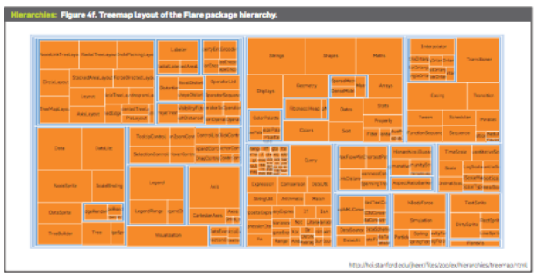Of the visualizations of Heer et. al, I find the most difficult to understand the following picture (figure 4f). It consist of only cubes, and it’s not a very common visualization. So at first sight it’s really not clear to me what they want me to tell with this picture. The design is not really spectacular, as some other designs are. And also they only make use of the color orange, which at first sight doesn’t give you any distinctions between things. It actually looks a bit like the map of the United States. But the article calls it an encolusre diagram, which represents hierarchy by using containment rather than adjacency to represent the hierarchy. It sucdivides the areas into rectangles. The size of a node is in this way quickly revealed.
2. In figure 1A the y-axis is changing all the time, which makes it not really nice to watch in my opinion. You have to think really good what scale you see at that moment and what scale your next mousemovement gives you.